CHARLES NORMAN BROCKBANK
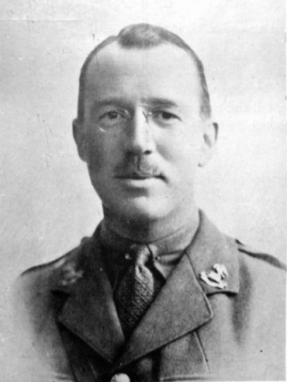
Rank: Captain
Date of Death: 01/07/1916
Age: 32 Regiment: The King's
(Liverpool Regiment) 18th Bn.
Cemetery: DANTZIG ALLEY BRITISH CEMETERY, MAMETZ Grave Ref: V. U. 8.
Additional Information: Son of Marion Annie Brockbank, of "Ulverscroft," 19, Adelaide Terrace, Waterloo, Liverpool, and the late R. M. Henry Brockbank.
An extensive biography appeared in Liverpool's Scroll of Fame. His photo appeared in the biography and is reproduced above with the kind permission of Liverpool Record Office.
CAPTAIN Charles Norman Brockbank was one of the first officers to be selected from the ranks of the "Pals." Like many other young patriots, he enrolled as soon as the call to arms sounded, and he was given his lieutenancy almost immediately. With him the gifts of leadership were transparent and supreme. The "Pals," moreover, demanded a specially high standard in their officers, and in this young and faithful soldier they found one who worthily honoured his calling. He helped in the training of the brigade, and he fell at the forefront of his men in that grim opening Battle of the Somme on July 1st, 1916. Further information on Charles Norman Brockbank can be found on www.merseysiderollofhonour.co.uk/database.htm
See plaque on the wall, here in St Nicholas’ Church, dedicated to this brave soldier.
ALBERT JOHN BROCKMAN
Rank: Second Lieutenant
Date of Death: 08/08/1916
Regiment: King's Own (Royal Lancaster Regiment) 4th Bn.
Memorial: THIEPVAL MEMORIAL in France
Panel Reference: Pier and Face 5 D and 12 B.
Additional Information: Son of John William & Mary Brockman
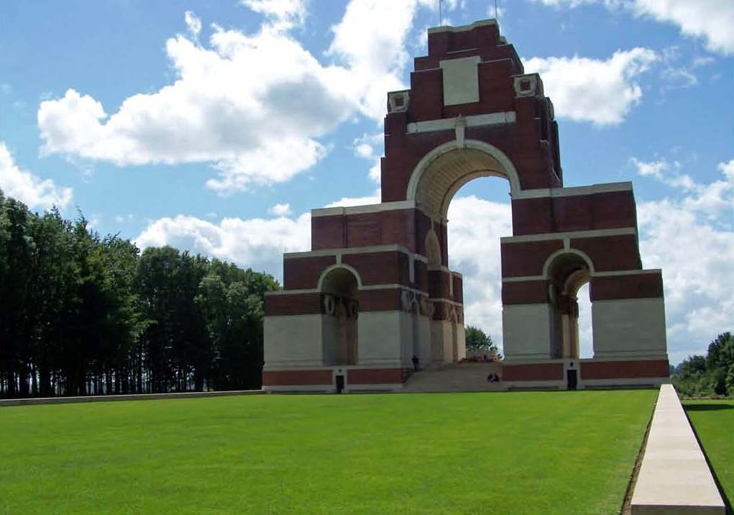
Thiepval Memorial
ROBERT JOSEPH COWMAN
Rank: Corporal Service No: 16087
Date of Death: 12/07/1916
Age: 22
Regiment: The King's (Liverpool Regiment) "D" Coy. 17th Bn.
Memorial: THIEPVAL MEMORIAL in France
Panel Reference: Pier & Face 1 D 8 B and 8 C
Additional Information: Son of Joseph Gregory Cowman and Margaret Watson Cowman, of 15, Coronation Drive, Great Crosby, Liverpool. Robert went missing at the Somme sometime between the 10th and 12th July. His parents received a letter from one of his comrades telling them that Robert had been badly wounded on the night of the 11th July but no further news of his fate ever came to light. His death was "assumed by Army Council for Official purposes" to have occurred on the 12th July.
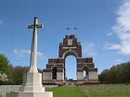
Thiepval Memorial
THOMAS HAROLD RAYNER DANIELS
Rank: Second Lieutenant
Date of Death: 09/04/1916
Regiment: King's Own (Royal Lancaster Regiment) 6th Bn.
Memorial: BASRA MEMORIAL
Panel Reference: Panel 7 , in Iraq

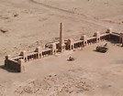
Basra Memorial, Iraq

MAXWELL HOOD-ROWAN
Rank: Second Lieutenant
Date of Death: 12/08/1916
Regiment/Service: King’s [Liverpool] Regiment [The Liverpool Pals] 1st/9th Battalion
Memorial: THIEPVAL MEMORIAL – Pier & face 1D, 8B & 8C.
Additional Information: Son of William and Eleanor Hood-Rowan, of Rowan Tree, Blundellsands, Liverpool.
Brother of Aitken Hood-Rowan.

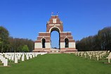
Thiepval Memorial

BERTRAM LE ROUGETEL
Rank: Corporal Service Number: 477535
Date of Death: 16/09/1916
Age: 29
Regiment/Service: Royal Canadian Regiment
Memorial: VIMY MEMORIAL
Additional Information: Son of Philip Le Rougetel, of 2 Oxford Drive, Waterloo, Liverpool and the late Susan Harvison Le Rougetel. Brother of Guy Le Rougetel.

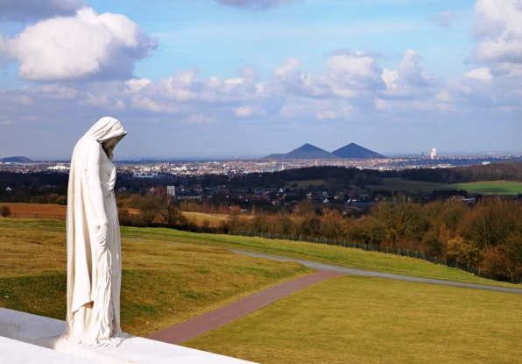
Vimy Memorial

GEORGE MARTIN
Rank: Private Service No: 267157
Date of Death: 16/08/1916
Regiment/Service: The King's (Liverpool Regiment) 13th Bn.
Memorial: THIEPVAL MEMORIAL in France.

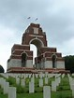
Thiepval Memorial

CECIL MAWDSLEY
Rank: Private Service No: 5539
Date of Death: 15/08/1916
Age: 19
Regiment/Service: The King's (Liverpool Regiment) 7th Bn.
Cemetery: ABBEVILLE COMMUNAL CEMETERY, France.
Grave Ref: VI. J. 2.
Additional Information: Son of Ellinor and the late James Mawdsley, of Blundellsands, Liverpool.
Son of Thomas and Sarah Ann Mawdsley, of "Marina," Holden Road, Blundellsands, Liverpool. He was buried in the family grave at St Helen's C.of E. graveyard, Sefton, on the 2nd February 1920. His place of death was given as 'Marina', Holden Road, Blundellsands and he was described as "late Army". The inscription on the grave reads: “In loving memory of Sarah Ann beloved wife of Thomas Mawdsley of Blundellsands died 21st November 1940 in her 78th year. Also of the above Thomas Mawdsley died 12th July 1941 in his 80th year. And also their children, Tom died 1892 aged 6 years. Helen died 1900 aged 10 months. Elsie Atherton died 1904 aged 17 month. John died 1905 aged 11 years. Jane died 1918 aged 29 years. James died 1920 aged 28 years”
As this family gravestone does not give information about James' war service the grave is also marked by a CWGC stone.

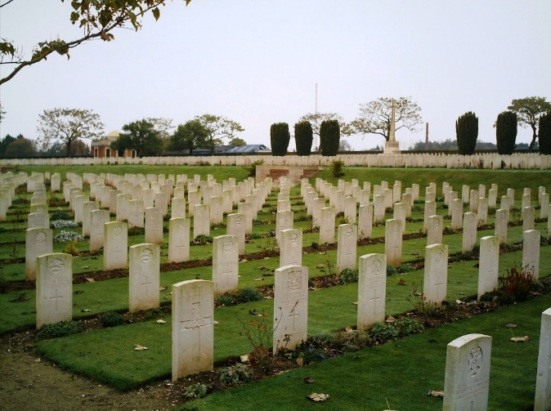
Abbeville Communal Cemetery in France

WILLIAM EDWARD MAYCOX
Rank: Sergeant Service No: 39009
Date of Death: 28/10/1916
Age: 20
Regiment/Service: South Wales Borderers 2nd Bn.
Cemetery: ETAPLES MILITARY CEMETERY, France.
Grave Reference: VIII. E. 3A.
Additional Information: Son of Tom and Mary Jane Maycox of 139 Brighton Road, Great Crosby. Native of Blundellsands.
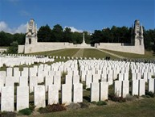
Etaples Military Memorial
A report on his death appeared in the Bootle Times on the 6th Nov 1915. His photo appeared in the report and is reproduced here with the kind permission of the Liverpool Daily Post & Echo.

A CROSBY BORDERER. DIES OF WOUNDS IN FRENCH HOSPITAL.
‘Widespread sympathy has been expressed with Mr. and Mrs. Maycox, of 139, Brighton-road, Great Crosby, who recently lost their eldest son in the war. Sergt. Wm. Edward Maycox, of the South Wales Borderers, was a descendant on his mother's side from a well-known Bootle family, being the eldest grandson of the late Mrs. Williams, 4, Keats Street. Born at Crosby just over twenty years ago, young Maycox received his early education at St. Nicholas' School, Blundellsands. On leaving school he took up his father's trade of a stonemason, being apprenticed with Mr. T. Banner, of Blundellsands. In youth he joined the Boys' Brigade, and the knowledge of drills and military movements he thus acquired served him in good stead when he subsequently entered the Army. Maycox had not completed his apprenticeship when war broke out, but his employer made no trouble about permitting him to join H.M. Forces.

On April 1st, 1915, Maycox joined the R.W.F. He was a steady lad, and his exemplary conduct, combined with a good prior knowledge of military tactics soon secured him promotion. He was quickly made a corporal, and in due course attained the rank of sergeant. After being at camps in different parts of the country and taking his musketry course, he left for France on May 31st last year, and was unfortunately wounded on June 19th. After a course of hospital treatment in England, Maycox was transferred to the South Wales Borderers, again went out to France on September 28th, and was wounded in a battle on the Somme on October 19th. He was carefully treated at a hospital in France, but alarming symptoms developed. On October 23rd, the parents received a telegram intimating that he was seriously ill. The mother went over, saw her son on the 26th, and he then appeared to be getting along splendidly. His mother had the satisfaction of conversing with him, and he expressed a strong desire to get home. The chaplain, he said, had given him Communion. Again matters took a bad turn, and the patient died on the 28th. Death was certified as injury in the back and bowel. A shot that struck him in the thigh set up septic poisoning, which it was impossible to combat.

Another son of Mr. and Mrs. Maycox - Thos. Alfred - aged 19, is a corporal in the Machine Gun Section at Salonica. He, too, is an old St. Nicholas' boy, and had a partial military training in the Boys' Brigade. He was learning the handicraft of a joiner with Mr. Burns, of Litherland. Joining on Nov. 3rd, 1915, he went out on August 31st last, and celebrated his nineteenth birthday at Salonica. On hearing of his elder brother's death, the young corporal wrote a comforting letter to his mother. In this he said, "It makes me feel proud to think I had a brother who did his duty so nobly." Two younger sons are also in the Boys' Brigade’. Bootle Times 6th November 1915

NORMAN LESLIE MITCHELL
Rank: Sergeant Service No: 23115
Date of Death: 30/07/1916
Age: 20
Regiment/Service: The King's (Liverpool Regiment) 20th Bn.
Memorial: THIEPVAL MEMORIAL in France
Panel Reference: Pier and Face 1 D 8 B and 8 C.
Additional Information: Son of John and Margaret Mitchell, of 17, Hastings Rd., Waterloo, Liverpool.
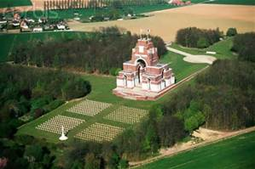
Thiepval Memorial

THEODORE WILLIAM SUTTON NEAME
Rank: Private Service No: 15831
Date of Death: 21/06/1916
Age: 19
Regiment/Service: The King's (Liverpool Regiment) 17th Bn.
Cemetery: CERISY-GAILLY MILITARY CEMETERY, France
Grave Ref: II. L. 3.
Additional Information: Son of Theodore and Jeannette Neame, of 1A, King St., Wrexham.
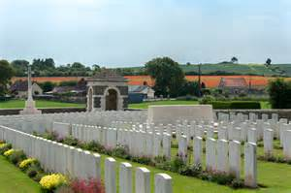
Cerisy-Gailly Military Cemetery

JOHN HARTLEY PEARSON
Rank: Private Service Number: 22211
Date of Death: 01/07/1916
Regiment/Service: King’s [Liverpool Regiment] - The Liverpool Pals 20th Battalion
Memorial: THIEPVAL MEMORIAL – Pier and Face 1B, 8B and 8C.
Additional Information: Duty in France and Flanders. Residence in Blundellsands, Lancashire.

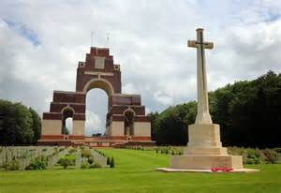
Thiepval Memorial

HERBERT ANGUS RILEY
Rank: Second Lieutenant
Date of Death: 28/06/1916 Age: 19
Regiment/Service: The King's (Liverpool Regiment) 1st/9th Bn.
Cemetery: WAILLY ORCHARD CEMETERY in France
Grave Ref: I. D. 2.
Additional Information: Son of C. Herbert and E. Iona Riley, of "Carlton," Warren Rd., Blundellsands.

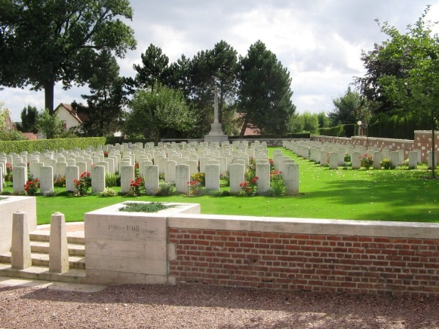
Wailly Orchard Cemetery in France

RICHARD VAUGHAN ROBERTS

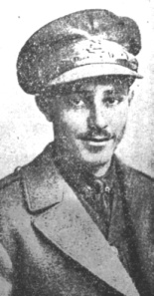
Rank: Lieutenant
Date of Death: 30/07/1916
Age: 24
Regiment: The King's (Liverpool Regiment) 19th Bn.
Cemetery: BERNAFAY WOOD BRITISH CEMETERY, MONTAUBAN in France
Grave Reference: L. 72.

Additional Information: Son of Dr. W. Vaughan Roberts and Mrs. B. Vaughan Roberts, of Minafon, Blaenau-Festiniog, Merioneth.

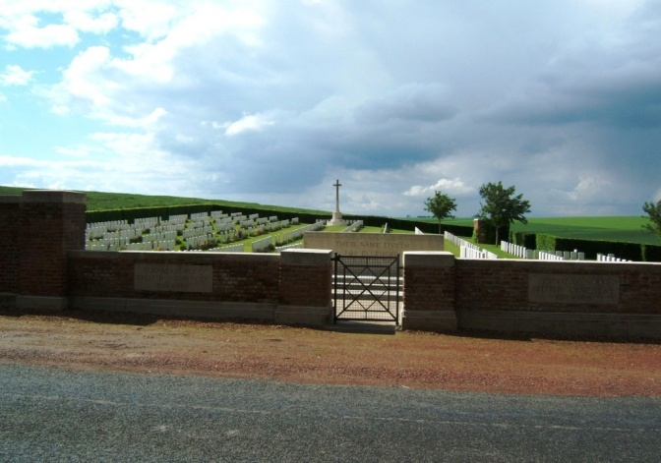
Bernafay Wood British Cemetery

GEORGE ERIC THOMPSON

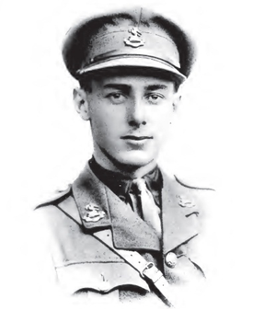
Rank: Second Lieutenant
Date of Death: 03/09/1916
Age: 20
Regiment/Service: The King's (Liverpool Regiment) "C" Coy. 4th Bn.
Memorial: THIEPVAL MEMORIAL in France
Panel Ref: Pier and Face 1 D 8 B and 8 C.
Additional Information: Son of George H. and Gertrude F. Thompson, of The Barn, Formby, Lancs. A Report from the Liverpool Echo 11th Sept 1916:-
“WELL-KNOWN LIVERPOOL OFFICER KILLED”
A well-known Liverpool officer, Second Lieutenant, George Eric Thompson, of the K.L.R., has been killed in action.
Second-Lieutenant Thompson was the elder son of Mr. and Mrs. George Thompson, of "Parkfield", Freshfield, and was twenty years of age. He was educated at Dunchurch Hall, Rugby, and at Harrow, playing for the school at cricket against Eton and at football against Winchester.
After leaving school he joined the staff of Messrs. Milligan and Mackintosh, cotton merchants, Liverpool, and became a playing member of the Northern Cricket Club and the West Lancashire Golf Club.
He enlisted in a Liverpool Regiment shortly after war broke out, and obtained his commission in December, 1915. He had been seven weeks at the front. His colonel writes that he was killed whilst leading his platoon into action.
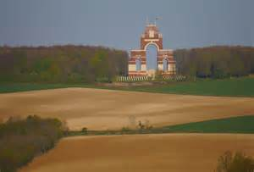
Thiepval Cemetery

