In May 1915, St. Nicholas’ Church Vicar, The Reverend Canon M. Linton Smith, having volunteered to serve, was appointed Army Chaplain to the Liverpool City Brigade; giving him a parish of 5,000 men stationed near Grantham. He was sent on active service in November of that year. (St Nicholas’ Parish remained in the care of two curates, Dr Guest and Mr Hartley).
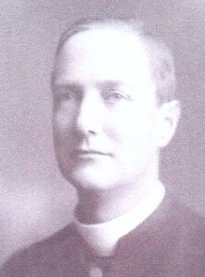
His March 1915 letter movingly describes the confirmation classes and service held for 22 men, held under the most difficult of circumstances. He clearly regretted the severance of his connection with the City of Liverpool Brigade when he was later appointed to Headquarters to supervise the work of the church in the whole division.
From parish magazines, we know that by the start of 1915, forty men from the parish were already on active service. By June, the first five names were entered on the Parish Roll of Honour and this number was added to in July.
Canon Linton Smith’s August letter describes the “big push” and its consequences:
“The war is giving a new meaning to the idea of self-sacrifice for us all. At the front the church is doing work for the social well-being of the army”.
The magazines of 1916 contain regular letters from Canon Linton Smith, now serving on the front line. He is full of admiration for the work of his fellow chaplains, “due largely to the energy and resourcefulness of Bishop Chavasse’s son, who is Chaplain in the division we have followed”.
In October 1916, he visits the front lines and provides some idea of life in the trenches, declaring his admiration for those who are serving, whom he describes as “the lost generation”. He was himself awarded the DSO in the New Year’s Honours List of 1917 for services in the field: in the battles of the Somme, of Arras and others. In the early part of 1917 Canon Linton Smith resigned from St Nicholas’ Parish. In St. Nicholas’ Parish, the Roll of Honour continued to grow.
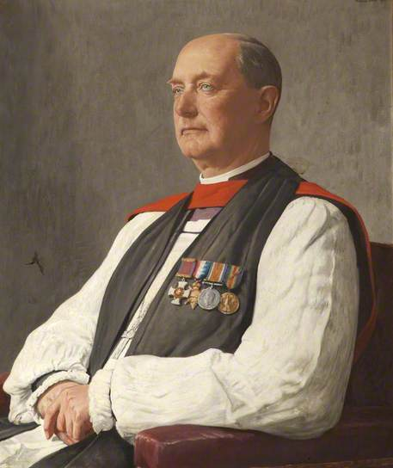
Portrait below was painted by Francis Dodd
The Right Reverend Martin Linton Smith (b.1869-d.1950) story continued. He was an Anglican Bishop who served in three Dioceses during the first half of the twentieth century, Bishop of Warrington (1918–1920), Bishop of Hereford (1920–1930), Bishop of Rochester (1930–1939), and Honorary Fellow (1930). . He was born on 4 July 1869 into a clerical family, his father was Dean of St David’s Cathedral, and was educated at Repton and Hertford College, Oxford.

